**Technical Architecture:**

Project Design Phase-II Technology Stack (Architecture & Stack)

|  |  |
| --- | --- |
| Date | 3.11.2022 |
| Team ID | PNT2022TMID11549 |
| Project Name | SMART WASTE MANAGEMENT SYSTEM FOR  METROPOLITAN CITIES |
| Maximum Marks | 4 Marks |

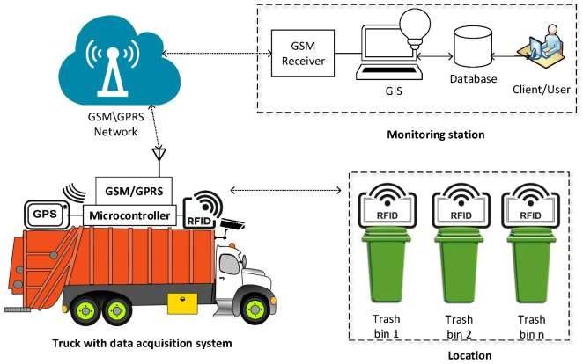

* Our waste management system provide real time monitoring to the garbage bins placed in various locations.
* The garbage bins are build with a sensor module(Ultrasonic sensor) which continuosly monitors the garbage bin.
* Any moment the garbage level passes over the critical level (i.e 80%),the system generates a notification to the monitoring panel (admin panel /garbage cleaning team) and so the cleaning team collects the garbage from the identified garbage bin.